BUAN/OPRE 6398.003 Prescriptive Analytics

Homework 5

Team 6

Taeho Kim
Lin Li
Madhuri Kashyap
Manasa Venkatesh
Thomas Trieu
Yu-Min Wang

2.
Let X = number of ITC class to be scheduled daily
Y = number of CWP class to be scheduled daily

Maximize Z = 360X + 150Y
Subject to:
15X + 6Y ≤ 112
3X + 6Y ≤ 50
X, Y ≥ 0 and integer

By Solver we get the following answer report.
The optimal solution is (X*, Y*) = (7,1) and Z* = $2670
There should be 7 ITC classes and 1 CWP class to be scheduled and the optimal daily profit is $2670.

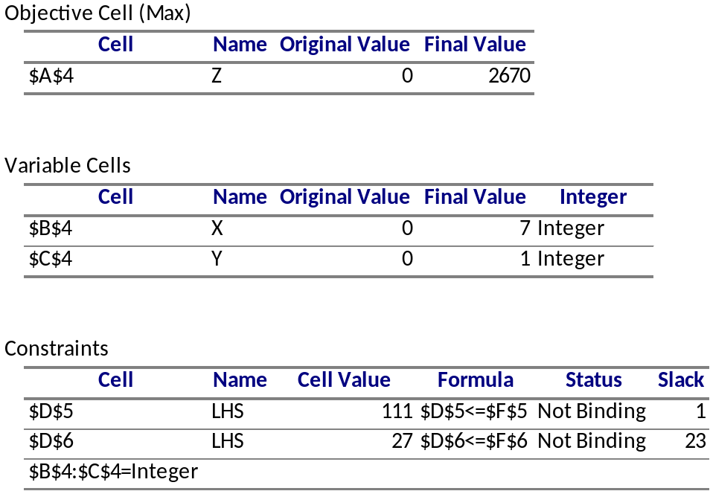

3.
Let X = number of 55-gallon drum to be produced
Y = number of gallon in bulk form
Maximize Z = 50X + 1.25Y
Subject to:
33.34X + 0.88Y ≤ 2000
26.66X + 0.5Y ≤ 1500
1.06X + 0.08Y ≤ 160
X ≥ 0 and integer
Y ≥ 0

By Solver we get the optimal solution (X*,Y*) = (47, 492.0682), optimal objective function value Z*=$ 2965.085

4.
(1)
Let X11 = 1 if GH swims FR, 0 otherwise
X12 = 1 if GH swims BR, 0 otherwise
X13 = 1 if GH swims BU, 0 otherwise
X14 = 1 if GH swims BA, 0 otherwise
X21 = 1 if MS swims FR, 0 otherwise
X22 = 1 if MS swims BR, 0 otherwise
X23 = 1 if MS swims BU, 0 otherwise
X24 = 1 if MS swims BA, 0 otherwise
X31 = 1 if JM swims FR, 0 otherwise
X32 = 1 if JM swims BR, 0 otherwise
X33 = 1 if JM swims BU, 0 otherwise
X34 = 1 if JM swims BA, 0 otherwise
X41 = 1 if CJ swims FR, 0 otherwise
X42 = 1 if CJ swims BR, 0 otherwise
X43 = 1 if CJ swims BU, 0 otherwise
X44 = 1 if CJ swims BA, 0 otherwise
Minimize Z = 55X11 + 55X12 + 52X13 + 54X14
+ 52X21 + 58X22 + 53X23 + 53X24
+ 51X31 + 54X32 + 55X33 + 57X34
+ 57X41 + 55X42 + 56X43 + 54X44
Subject to:
X11 + X12 + X13 + X14 = 1
X21 + X22 + X23 + X24 = 1
X31 + X32 + X33 + X34 = 1
X41 + X42 + X43 + X44 = 1
X11 + X21 + X31 + X41 = 1
X12 + X22 + X32 + X42 = 1
X13 + X23 + X33 + X43 = 1
X14 + X24 + X34 + X44 = 1

X11, X12, X13, X14, X21, X22, X23, X24, X31, X32, X33, X34, X41, X42, X43, X44 = 0 or 1

(2) The Answer Report is as below.
The optimal solution (X11*, X12*, X13*, X14*, X21*, X22* X23*, X24*, X31*, X32*, X33*, X34*, X41*, X42*, X43*, X44*) = (0,0,1,0,0,0,0,1,1,0,0,0,0,1,0,0), Z*=211
That means GH should swim BU
MS should swim BA
JM should swim FR
CJ should swim BR
The minimum total team swimming time is 211 seconds.

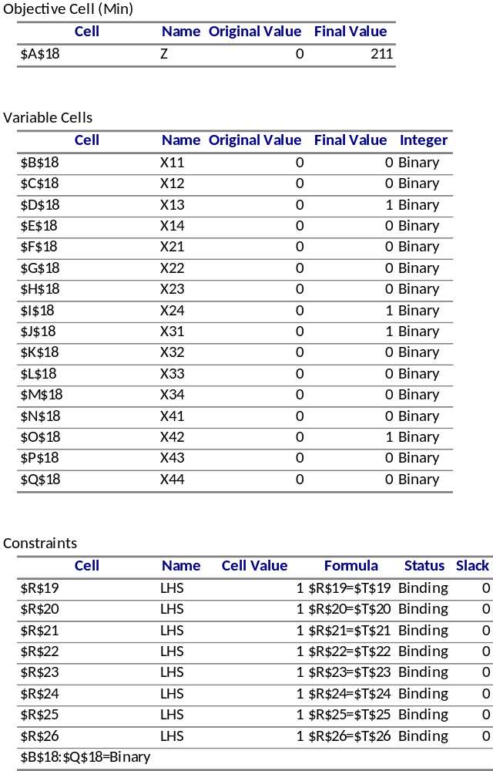

5.
(1) Let Xi = 1 if a camera is located in location i, 0 otherwise, i=1…12
Minimize Z = X1 + X2 + X3 + X4 + X5 + X6 + X7 + X8 + X9 + X10 + X11 + X12
Subject to:
X9 = 1
X1 + X9 + X12 ≥ 2
X2 + X5 + X9 + X10 ≥ 2
X8 + X12 ≥ 1
X2 + X11 + X12 ≥ 1
X10 ≥ 1
X1 + X2 + X4 + X8 + X12 ≥ 1
X11 + X12 ≥ 1
X2 + X7 + X11 ≥ 1
X10 ≥ 1
X5 + X8 ≥ 1
X4 + X10 ≥ 1
X1 + X8 + X11 ≥ 1
X10 ≥ 1
X7 + X8 ≥ 1
X7 ≥ 1
X5 + X7 ≥ 1
X1 + X7 ≥ 1
X6 + X9 ≥ 1
X9 ≥ 1
X3 ≥ 1
X6 + X9 ≥ 1
X3 ≥ 1
X5 ≥ 1
X3 + X6 ≥ 1
X6 + X9 ≥ 1

Xi = 0 or 1, i=1…12

(2)
The Answer Report is shown below.
The optimal solution (X1*, X2*, X3*, X4*, X5*, X6*, X7*, X8*, X9*, X10*, X11*, X12*) = (1,0,1,0,1,0,1,0,1,1,0,1). Optimal objective function value Z*= 7

That means the 7 cameras are located in location 1,3,5,7,9,10,12

